Personal Portfolio Website Plan

# Your Name: Katie Lininger

# Ideas for your website

Determine how you will use your personal portfolio website to showcase your skills.

Idea 1: Apply the right elements to ensure the website is compatible with all devices.

Idea 2: Create a unique design that sets my website apart from my competitors’.

Idea 3: Showcase coding skills using neat, easy-to-read code.

Idea 4: Incorporate interactive elements to keep the attention of the viewer.

Idea 5: Include photos of my code and the resulting webpages.

# Website Plan

|  |  |  |
| --- | --- | --- |
| **Topic** | **Questions** | **Answers** |
| **Purpose of Website** | What is the purpose and goal of the website? | The goal is to showcase my work and skills to any potential clients. |
| **Target Audience** | Describe the target audience (age, gender, demographics) | The target audience will generally be 25-55 year old employers and/or clients from the Northwest Missouri and Kansas City areas. |
| **Graphics** | What graphics will you use on the website? | Photos, buttons, personal logo. |
| **Color** | What colors will you use within the site to enhance the purpose and brand? | I will use neutral colors like white, brown, beige, and green as an accent color. |
| **Accessibility** | How will the website accommodate people with disabilities? | I will implement high visual contrast for easier distinction and larger fonts. |
| **Project Timeline** | Identify the project timeline | The project timeline will be from early January to late April. |

# Wireframe

Sketch the wireframe for your home page below.

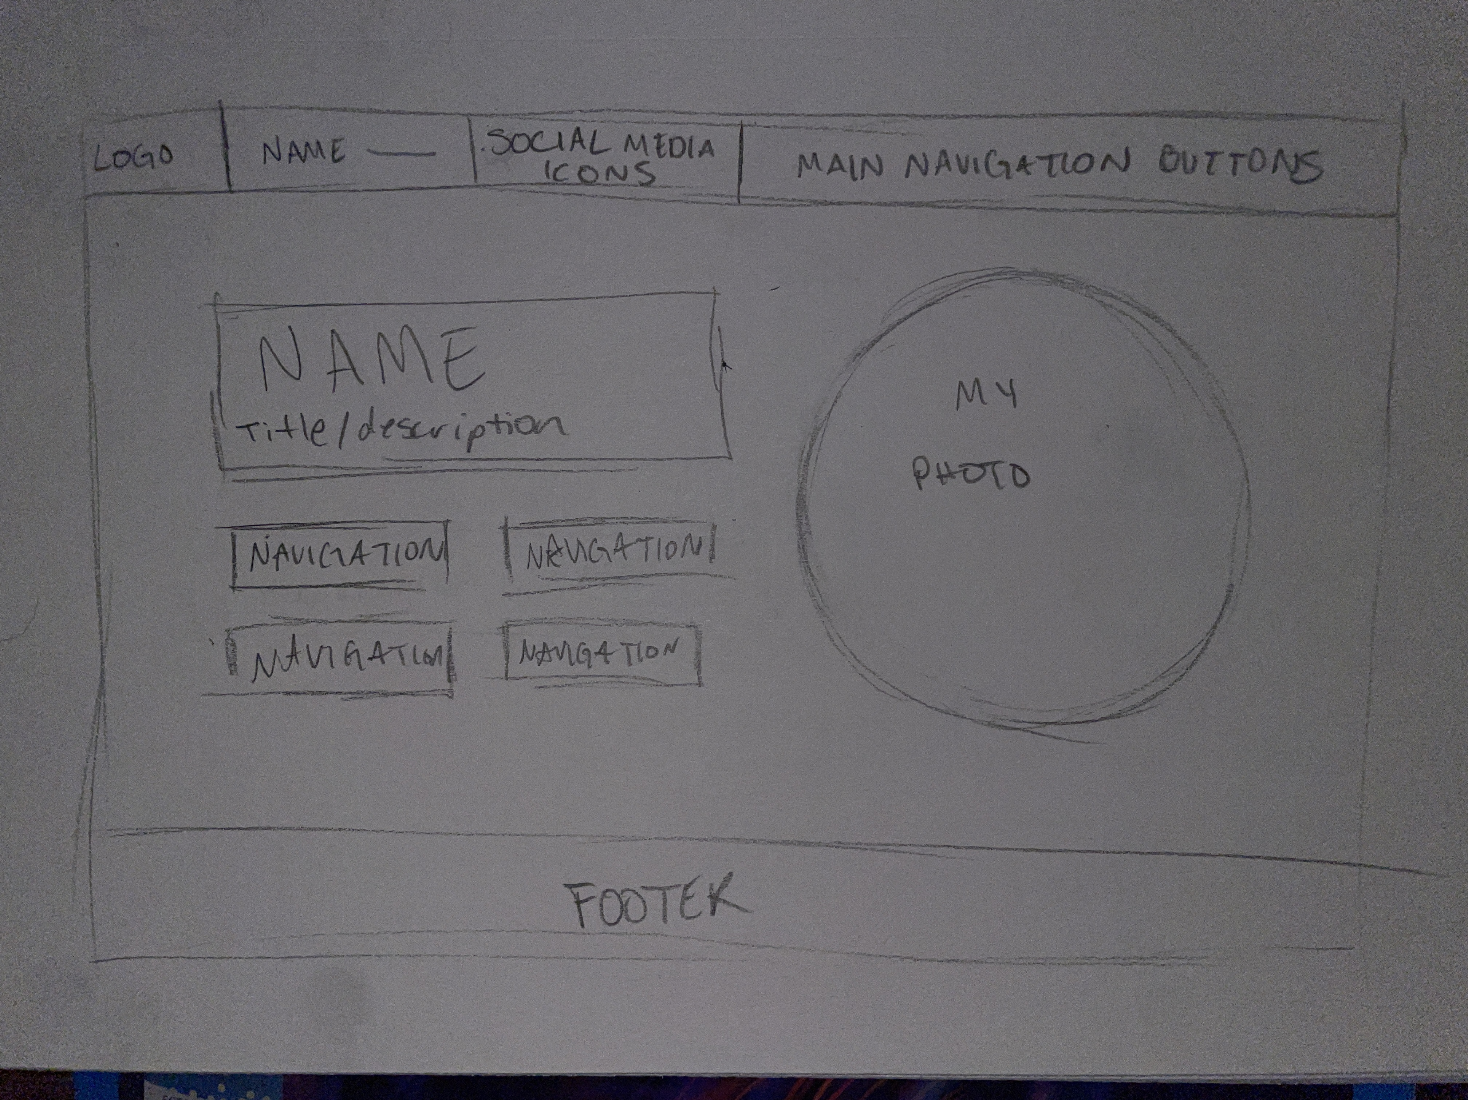

# Site map

Create a site map for the website below.

